Wizards Solution

Exercise 1: Investigation

Answer the following questions about the FNOL wizard PCF file.

1. What is the name of the first wizard step? What is the name of the screen it points to?

FindPolicy; FNOLWizard_FindPolicyScreen

1. How many wizard step sets are there in the wizard?  
     
   Three
2. In the GeneralPropertyWizardStepSet, how many of the steps have at least one Next condition?  
     
   One (ClassicPartiesInvolved, which goes to ClassicAssign)
3. Which property of the wizard is used to specify the message to display when a user attempts to cancel out of the wizard. (This was not explicitly discussed in the presentation, but you should be able to determine this by reviewing the wizard PCF file.)  
      
   cancelWarning
4. What must be true in order for the Services wizard step to be available?  
     
   The code for the IsServicesStepAvailable function can be found on the “Code” tab on the Wizard itself. According to this function, the Services step will be available when the policy type is anything other than workers’ comp, personal travel, or null.

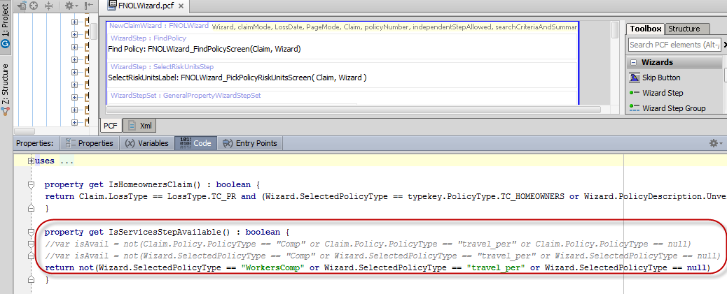Exercise 2: Configuration

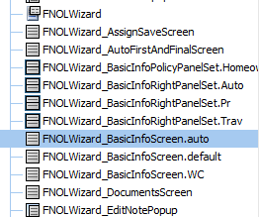

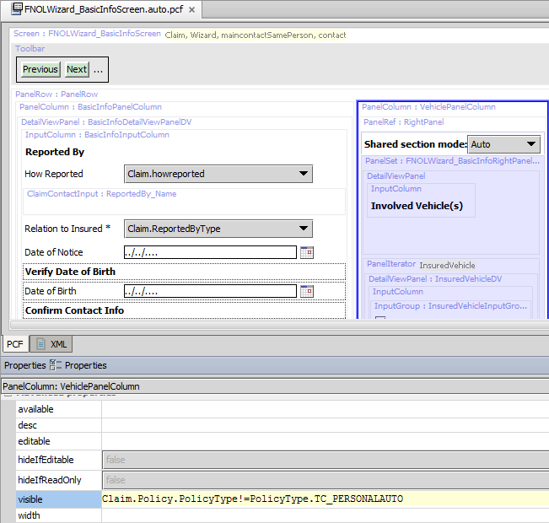

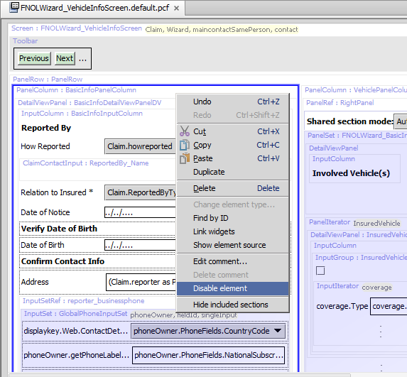

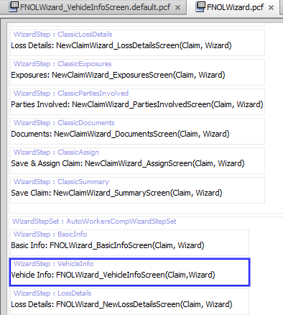

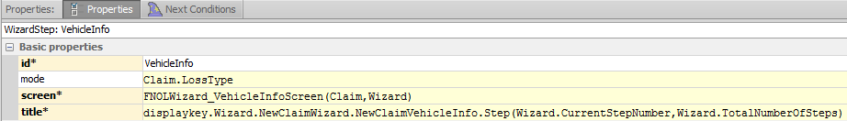

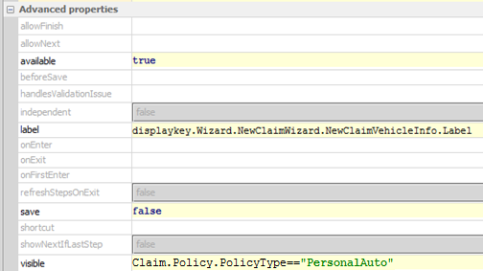

New Display Keys:

